**Attempt all questions**

1. Write a command to check our windows version.

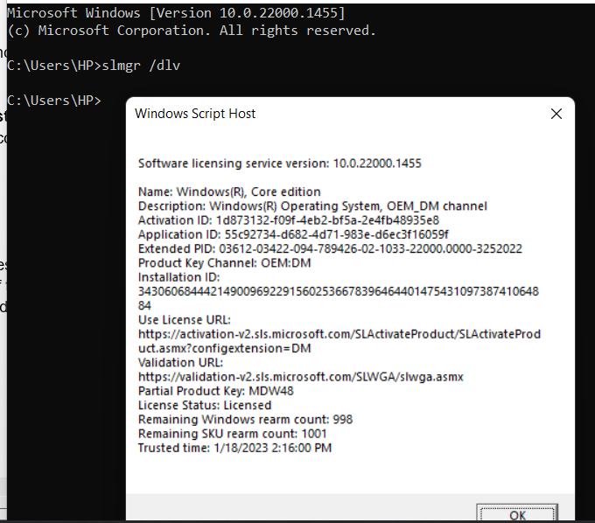

1. Create the directory date. Within that directory create a text file to show the current system date.

1. Show the system information using the command.

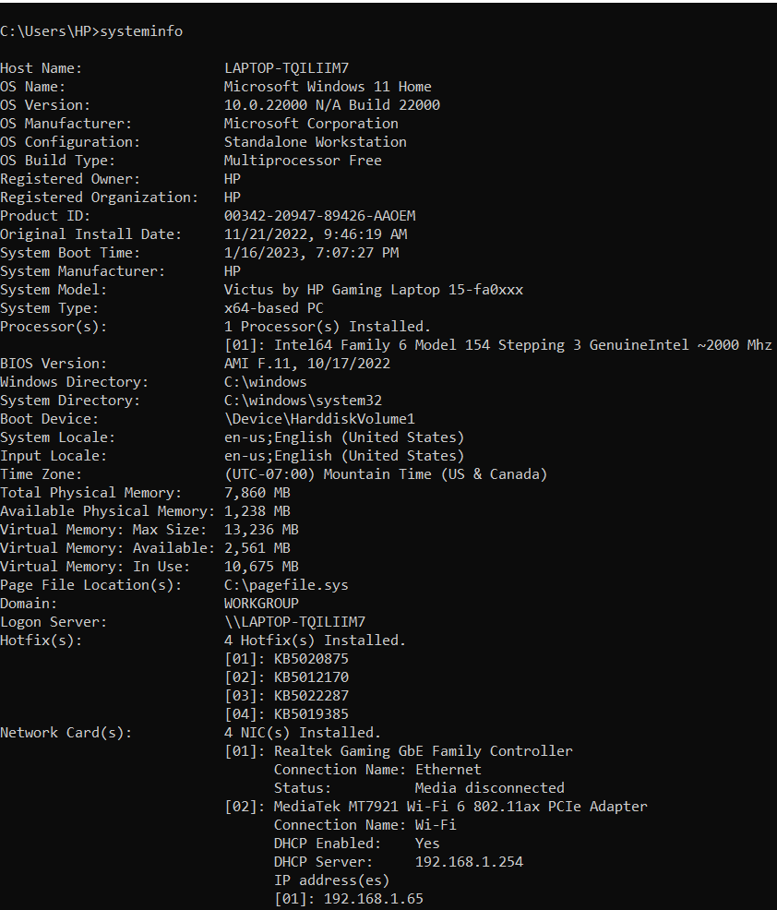

1. Create the directory called **system Info** and create the file name **systemInfo.txt**. In that file all your system information should be auto generated using the command.

1. Launch the **systeminfo.txt** using notepad using the command.

1. Briefly explain about the Ping, getmac, ipconfig command.

Ping: Ping, often referred to as packet internet or inter-network groper, is the length of time that a server takes to react with data to a user.

Getmac: The Media Access Control (MAC) address is displayed by the command getmac.

Ipconfig: A command called "ipconfig" shows the computer's current IP addresses. Internet Protocol Configuration.

1. Ping the google domain and paste the screenshot.

1. Show the ip address of your device.

1. What is the use of the FC command?

* The fc command is a command-line tool for listing, modifying, and re-executing commands that have already been input into an interactive shell.

1. Create the directory called difference. In that directory create two files File1.txt and File2.txt. Add contents in 2 files and perform the ascii comparison of these 2 files.

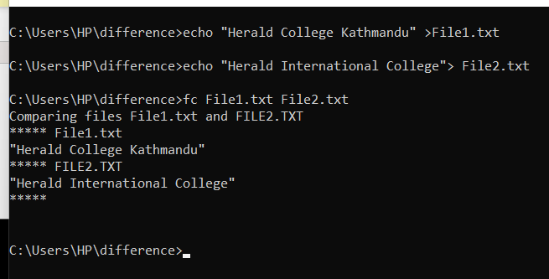

1. Generate the power efficiency diagnostics report using the command.

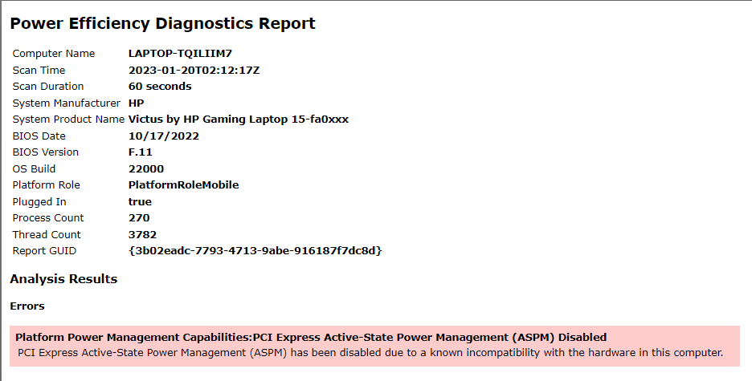

1. What does the CHKDSK do?

* Examining disk spaces, checking files, and correcting errors are all functions of CHKDSK.

1. Explain doskey /history command.

* The command Doskey /history allows users to save history while also displaying the history of all recently typed commands.